**Advance Excel Assignment 3**

1. How and when to use the AutoSum command in excel?

If we need to sum a column or row of numbers, let Excel do the math for us. Select a cell next to the numbers we want to sum, click **AutoSum** on the **Home** tab, press **Enter**, and we are done.

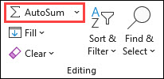

When we click **AutoSum**, Excel automatically enters a formula (that uses the SUM function) to sum the numbers.

Here is an example. To add the January numbers in this Entertainment budget, select cell B7, the cell immediately below the column of numbers. Then click **AutoSum**. A formula appears in cell B7, and Excel highlights the cells we are totalling.

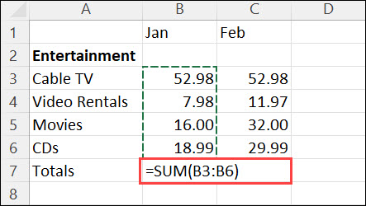

Press Enter to display the result (95.94) in cell B7. We can also see the formula in the formula bar at the top of the Excel window.

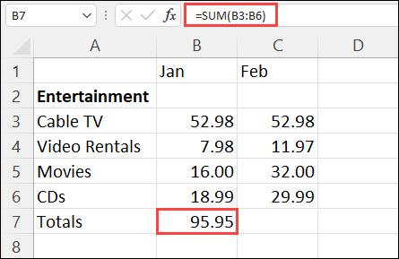

1. What is the shortcut key to perform AutoSum?

AutoSum is a fast, easy way to add up multiple values in excel. We can access the AutoSum command from either the home tab or the Formulas tab, but there is a keyboard shortcut that makes it even faster: **Alt+=**

1. How do you get rid of Formula that omits adjacent cells?

* The error formula omits adjacent cells means that Excel cannot calculate the formula because it is missing something.
* Excel tries to calculate a formula but only considers the values from one cell, ignoring other cells with values needed for the calculation.
* If this happens, it means that you have left out a cell on one side of your formula and need to clean up your sheet.

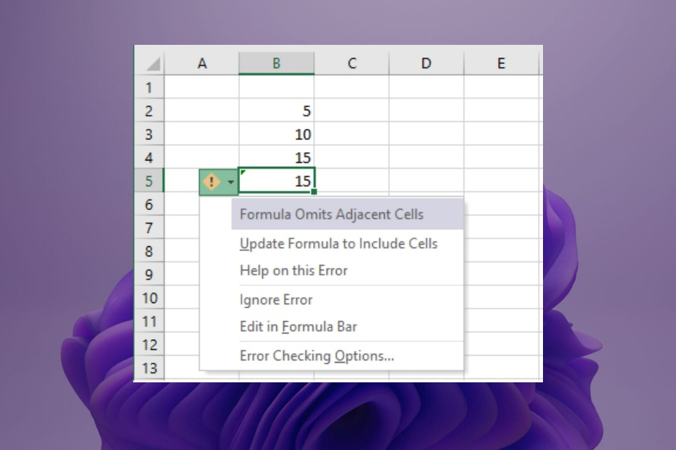

If we get an error message saying that your formula omits adjacent cells when you try to enter it, your Excel spreadsheet has probably been modified.

Getting rid of formula that omits adjacent cells:

* First, check to make sure that your formula includes all of the necessary parts.
* If you are working with a small data set, try to identify any empty cells and delete them.
* **Uncheck formulas that omit cells**

1. Launch your Excel sheet and then click on **File**.
2. Navigate to Options and then select **Formulas**.

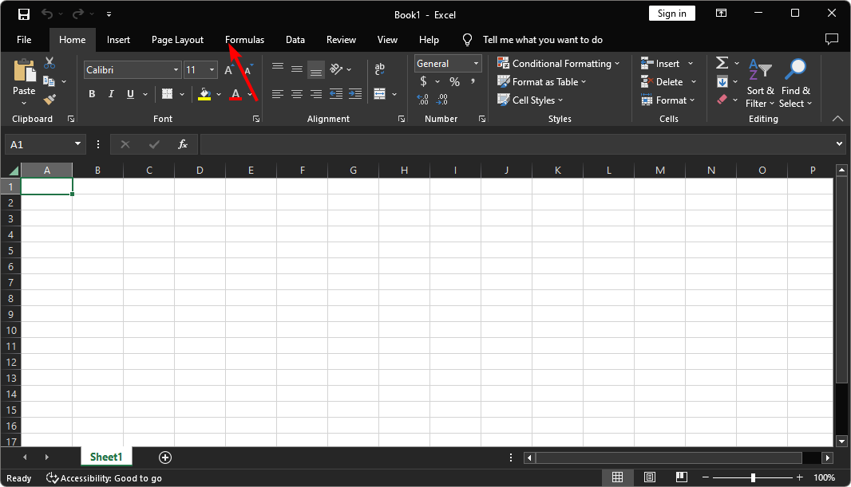

1. Look for Error checking rules and uncheck **Formulas which omit cells in a region**.

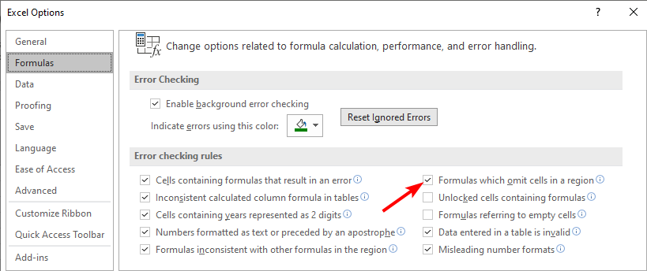

1. Click OK.

* **Switch from absolute to relative reference**
  1. Open the Excel sheet and select the cell that contains the formula.
  2. Navigate to the formula bar at the top and press F4 until you get the relative reference option.

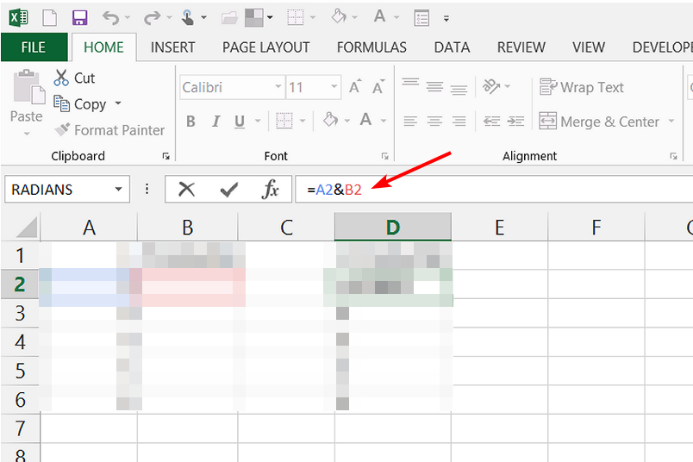

1. How do you select non-adjacent cells in Excel 2016?

To select non-adjacent cells and cell ranges, **hold ctrl and select the cells.**

1. What happens if you choose a column, hold down the Alt key and press the letters ocw in quick succession?

Alt key and ocw is an excel shortcut to make all columns wide enough for the values in the column.

1. If you right-click on a row reference number and click on Insert, where will the row be added?

By right clicking on a row reference number and clicking on insert the row will be added above the selected row.